From a Mental Health Professional and Supporter of the Revolution...
Step Up to My $1000 Challenge to Support the National Revolution Tour

I will double your donation to the National Get Organized for an ACTUAL Revolution Tour, up to $1,000, received by May 4. The National Get Organized for an Actual Revolution Tour goal: to spread the word and bring people into the process of building for an actual revolution.



I have searched my heart and soul, and either I choose to accept to live in a world based on heinous brutality and crimes against humanity in the US and around the world, or I stand up and fight for revolution. It is through studying the scientific work of Bob Avakian, that I am convinced that the only way out of this hell, is through a revolution that digs up this system's rotten roots and brings into being a whole new system that is not built on exploitation, but on the needs of the people and the highest aspirations of humanity.

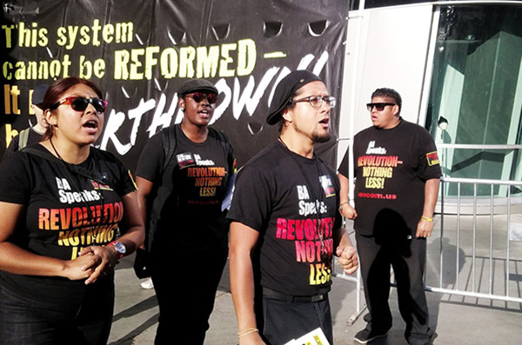

I weep when I hear about the children in cages at the border with Mexico. I am enraged when time and time again, the lives of Black and Brown people are stolen by murdering pigs with no repercussions; and how the youth in the ghettos are pitted against one another to kill for a spot on the corner that is not theirs anyway. I am horrified when I imagine what it is like to be a Palestinian, forced to live, and barely survive, in an open air prison in Gaza. I am shocked when we can see and feel the actual climate disruption causing death and destruction all over the planet and there are no viable plans to stop it. I stand with my sisters who have been sexually harassed, beaten and raped every minute in this patriarchy. I grieve with the LGBT community as they are targeted through actions of hate or die at alarming rates through suicide. I have come to understand through years of delving into the work of BA, that these things are the result of the workings of capitalism and imperialism.

This kind of world is intolerable to me and it should be to you! If you REALLY get into this revolution, you will learn that the world does NOT have to be this way.

If you contribute to support this tour, you can help make it possible for hundreds and thousands of people to have the opportunity to learn about what this revolution is all about, what difference it can make in the world, and how we can win.

I am inspired by what the revolutionaries on the tour are doing. I loved that Noche Diaz presented a fire extinguisher award to Al Sharpton as a symbol that he plays the role of “extinguishing the fire” of outrage and desire to stand up to the powers that be and pulling them back into the system that causes needless suffering in the first place.

It was powerful that a white male comrade was kicked out of a “safe space” because he read a poem written about sexual trauma against women. There are no safe spaces in the world we live in and the team came back standing firm against intersectionality with the message that this would not lead to emancipation. The revolutionaries are out front at the Bernie Sanders rallies going up against the Bullshit of the democrats and solutions that will lead nowhere.

This Tour urgently needs our contributions to stay on the road -- for travel costs; lodging; printing costs; supplies; food; reading materials and more. This revolution is the only hope for a world without borders; a world where people can live in dignity no matter their race or gender or whom they love; a world where the planet is protected; where there are no wars for empire; and a world in which life is worth living.

Join me in donating to make this possible. Do it now, before May 4 and double your impact with my dollar for dollar match!
With warm thanks,
A Mental Health Professional and Supporter of the Revolution

Go revcom.us to learn more about the tour, stay abreast, and find out more ways you can support the tour.

